Ethos Statement
MSLETB is a community of learners with an historic and unique tradition as a provider of education and training. In responding to the needs of the community, it delivers the highest standards of teaching and learning.

MSLETB Colleges, Schools and Centres of Education are democratic, co-educational and multi-denominational in character where policies, practices and attitudes are underpinned by the core values of Respect, Equity and Fairness.

The Board of Management of Grange PPS is publishing this document as the official Code of Behaviour. The ETB as patron of the school has approved this publication. Copies of the policy are available at the school and are furnished to each person who applies to be admitted to the school.

Link to Mission Statement
Grange Post Primary School is a partnership of Staff, Students and Parents enabling each student to achieve his or her full potential. We aim to inspire a Love of Learning in all our students, irrespective of ability and through personable and enthusiastic encouragement to lead all on to develop as Caring, Respectful Individuals in a challenging world.

The Code of Behaviour helps to set the standards that the school community aspires to and acts as a template which allows students and staff to work together to continue to develop the school and maintain its characteristic vision.

Positive Behaviour
The school recognises positive behaviour and achievements through the school journal, school trips and outings, annual awards ceremonies and publicity in local newspapers.

The school also attempts to encourage a positive school atmosphere through a focus on teaching and learning and a range of methodologies aimed at meeting the needs of the student. The school is presently integrating Assessment for Learning and Cooperative Learning strategies and continues to look at methods to encourage and assist learning. Class Tutors are also encouraged to employ restorative practices in their dealings with discipline issues. Support and training for such strategies is facilitated through the forum of school planning.

Attendance
Each student must:
- Adhere to the school timetable at all times and attend classes punctually.
- Have all necessary books and equipment with them.
- Produce an official absence note in their journal signed by parent/guardian to their tutor, who will give it to Ann, on the day of their return to school.
- Students are forbidden from leaving the school premises without permission from the Principal and those who break this rule incur an automatic suspension.
- Students leaving school early e.g. for authorised appointments must have an official note signed by parent / guardian in school journal and be collected by a parent / guardian at the school only.

Procedure when absent from school
Parents are asked to give written explanation of all absences in their child’s school journal. If a student is likely to be absent from school for longer than 2 days a phone call to the school informing us of this would be appreciated. (The written explanation in the school journal is also required on the child’s return to school.)

Please note that it is the duty of the management to report relevant students who have been absent from school for 20 days to the National Educational Welfare Board (NEWB).

Procedure when late for school
If a student is late for class he / she must sign in in the front porch before going to class. A record of lateness will be kept and where students are regularly late students will be spoken to and their parents/ guardian will be contacted by management.

Procedure when leaving school premises during day
If a student has to leave school during the school day, an e-mail, if possible, should be sent to the secretary or a signed note should be written in the student’s journal and brought to the office that morning. The student must sign ‘out’ on leaving and the student must sign ‘in’ on returning in the ‘Permission to leave school’ book at the office.
In exceptional circumstances local arrangements will be made.

It is school policy not to allow students to leave without a parent contacting the office to collect them. Please do not arrange to collect your son/daughter outside the school. When a parent / guardian calls to collect the student, they will then be called out of class.

School Uniform
All pupils must wear the school uniform and maintain it in a smart condition. Students may be requested to return home until the correct uniform is available to them. Students out of uniform may not be admitted to class and can be placed on immediate in-house suspension where no alternative solution is possible. This decision is at the discretion of the management.

- Full school uniform must be worn on all school trips and events, or when representing the school. Failure to attend to this will result in the student being unable to participate in the school outing.
- Due to Covid restrictions students are permitted to wear their own appropriate PE gear on the day they have PE.
- All students will be required to wear flat black leather shoes.
- Facial jewellery is not permitted (including tongue studs) .
- Earrings must be non-hooped (studs only) and only one in each lobe is permitted.
- Only school jackets are allowed on-site. Non-school jackets will be confiscated, unless a prior agreement has been made, and jackets may only be collected from the Deputy Principal by a parent.
- Non branded, appropriate face masks, i.e. the ones supplied by the school, are to be worn at all times- Snoods and scarves do not suffice as masks

Conduct
Each student must be respectful, courteous and cooperative to each other, to school staff and to visitors.
Bullying of any description will not be tolerated. A “hands off” policy will be implemented at all times.
Good behaviour is expected at all times:
- in classrooms
- on school premises/grounds and corridors
- on school buses and bus stop
- on all school outings.

Outside the school premises
Students are expected to keep all school rules and behave in a responsible way at all times when wearing the school uniform. This also applies when travelling to and from school, on school outings and when representing the school at games and other activities.
Substance Misuse
Smoking on school premises/grounds is illegal, including e-cigerattes.
Consumption of alcohol is forbidden, including on school trips.
The possession of and involvement in drugs or any prohibited substance is illegal.
Deodorants, aerosols and Tip-ex solvents are forbidden on school grounds.
Sanctions will apply in accordance with the code of behaviour.

Homework
Homework should be carried out in line with our Homework Policy.

Mobile Phones / Personal Devices
Use of mobile telephones or any technological devices including music devices e.g. iPods, on school grounds is forbidden. The school accepts no responsibility for devices that are damaged, lost or stolen while on school grounds. In the event of a student using a mobile phone or being seen with one it will be confiscated and a sanction applied. Phones will be stored in a secure location; however, the school takes no responsibility for phones lost, stolen or damaged while in storage.
The phone will only be returned to parents/guardians by appointment through the office, from the office by the Principal or Deputy Principal.
Students using their own technology in school, such as leaving a mobile phone turned on or using it in class, sending nuisance text messages, or the unauthorised taking of images with a mobile phone camera or device, still or moving are in direct breach of the school’s Acceptable Use Policy. (Please see school’s AUP). Where mobile phones are being used by a teacher for specific elements of the classroom- strict rules will be devised by the specific subject teacher, which students must adhere to.

Internet Usage
Misuse of the Internet may result in disciplinary action, including written warnings, withdrawal of access privileges and, in extreme cases, suspension or expulsion. The School also reserves the right to report any illegal activities to the appropriate authorities (Please see school’s AUP).

Students out of class
If a student needs to leave class they must seek permission from their teacher to be out of class. They must adhere to new one-way system in the school

Students going home for lunch
If students who live nearby wish to go home for lunch they should have a letter giving permission signed by a parent /guardian at the start of the year. A copy of this letter can be collected from the office. Junior students who go home for lunch must remain at home and cannot be up town during lunch time. A list of students going home for lunch will be available to teachers to view on VSWare.

School Property
It is an offence to damage or deface school property in any way. Students are expected to pay for and / or remedy damage which they have caused. Any interference with gas works, electricity, fire extinguishers and alarms will be deemed a most serious offence for safety reasons and will be dealt with accordingly.

Students are expected to keep classrooms and general school areas tidy and litter free.

School Discipline Structure

How the school’s discipline structure works

The system is based on three defining principles:
- Fairness
- Consistency
- A measured approach (ladder system).

Behaviours are classified according to their level of seriousness as follows:

- Low level breaches.
- Mid- level breaches.
- High level breaches.

Low level breaches:
Includes:
- Late for class/ school
- Incorrect shoes on astro-turf pitch.
- Missing classroom materials.
- Low level breach of “hands-off policy”
- Other offences deemed of low level by teachers that may arise

Sample “ Yellow” Discipline Sheet
Student: | Date: | Teacher:
1.
Description of discipline breach | Teacher intervention applied
- Late for class
- Missing class materials
- Not following teacher instruction(low level)
- Other
2.
Class: | Date:
Description of discipline breach |  | Teacher intervention applied
- Late for class
- Missing class materials
- Not following teacher instruction (low level)
- Other

3.
Class: | Date:
Description of discipline breach |  | Teacher intervention applied
- Late for class
- Missing class materials
- Not following teacher instruction (low level)
- Other
Mid- level Breaches:
Includes:
- No PE gear to class
- Out of bounds
- Class disruption
- Mild use of in appropriate language
- Mid level breach of “hands –off” policy
- Persistent inattention in class
- Other as deemed so by teacher

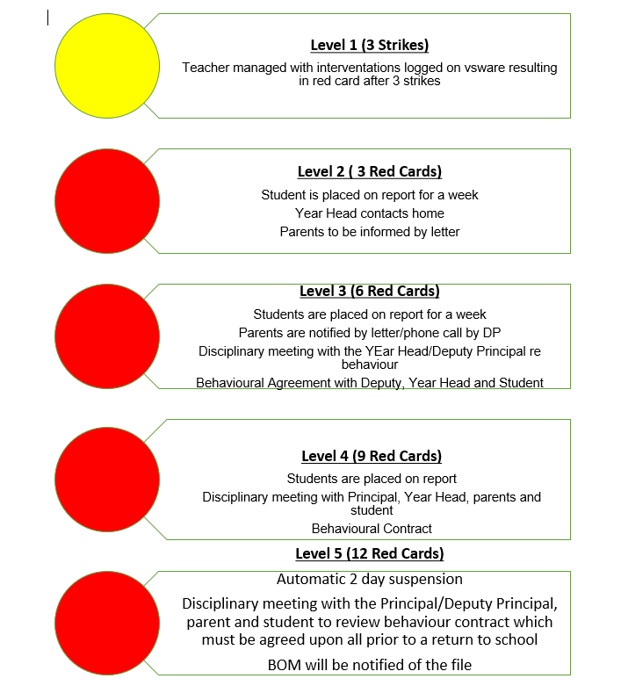

High-level Breaches:

Includes:
- Leaving school grounds without permission
- Outright defiance of a teacher/ staff member
- Bullying/ intimidation
- Physical violence/ overt aggression
- Deliberate damage to school property
- High level breach of “hands off” policy
- Smoking/ banned substance, use/ distribution
- Involvement in organised fights
- Use of strong inappropriate language
- Other instances deemed high level by Principal / Deputy Principal

Procedure: Complete necessary column on the red discipline sheet and refer student immediately to the Principal
(Deputy Principal in absence of Principal). Describe in detail the event on the back of the sheet.

Immediate sanctions to be applied ranging from removal from a class to Deputy Principal or Principal, parental meeting and or suspension, at the Principal’s discretion, with the needs of students a central consideration. Any detentions/ suspensions applied will not be taken into account when calculating suspensions under the mid-level system.
Where the removal of a student is deemed necessary an immediate report will be sought from the teacher, parents will be contacted and where warranted an up to 3 day suspension could occur
If more than two high level issues arise then a behavioural meeting will occur.
Where a student has been suspended three times for high level breaches, expulsion procedures can be considered.

In class discipline interventions
Where incidents of misbehaviour occur in class, teachers may employ any of the following:

- Discussion with student at end of class
- Extra school work to be completed at home or in school (including break and
- Note on VS Ware
- Moving students seating position
- Removal of privileges
- Verbal Warning

On Report
An online report will be issued to students by the Year Head. On completion of the report a copy will be sent to parents. It is the student’s responsibility to inform the teacher that he/she is on report and ask them to fill out the report card. Where the students comments are not deemed satisfactory by the Year Head the student will be placed on report for an additional amount of time, up to an additional week The student will be able to view their report on Office 365.
Should a student warrant a red card while on report, the card will be written and will accumulate in the usual manner.

If a student fails to complete the week satisfactorily sanctions, they may be kept on report for another week until their behaviour improves.

Enhanced Behavioural Expectations
In the current climate, where there is added pressure and stresses on 3rd and 6th year students and where it is deemed by the teacher that a student is denying his/her fellow students from learning the student will be removed from the class and sent home

Suspensions
In incidents where students are suspended, they will not be allowed to return to school until such time as their parent/guardians have attended a meeting in the school to discuss the cause of suspension.
Students will not be sent home until a parent/guardian has been contacted and arrangements made for the transport home of that student.

In the case of suspensions, the Board of Management will offer an opportunity for the parents of the student in question, or the student if over 18, to appeal the decision.

Where the total number of days suspension in the school year exceeds 20, the parents of the student in question, or the student if over 18, may appeal the decision under Section 29, Education Act 1998.
At the time when parents are formally notified of suspensions, they will be told about their right to appeal.

Exclusion
In extreme circumstances, the Board of Management (under authority devolved by MSLETB) may move to expel a student from the school. This may be for persistent, significant disruption to the teaching process and the learning of others, a student presenting a real and significant threat to safety, serious damage or other serious breaches of the Code of Behaviour.

In the case of expulsions, the following steps will be followed:

