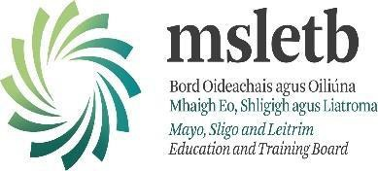

Additional Educational Needs Policy

A Whole School Approach

The policy is a revision of the 2015 Grange P.P.S. SEN Policy.
Legal Framework
This policy is informed by the following legisation;
- The Education Act (1998)
- The Equal Status Act (2000),
- The Equality Act (2004),
- The Education Welfare Act (2000),
- The Data Protection Acts (1988, 1998 and 2003)
- The Education for Persons with Special Educational Needs Act (2004).
- Circular No 0014/2017 -Circular to the Management Authorities of all Mainstream Post Primary Schools
- Circular 0055/2022- Exemptions from the study of Irish – post primary.
- GDPR Legisation
Four further publications have informed the content of this policy:
- “Inclusion of Students with Special Educational Needs- Post Primary Guidelines” (Department of Education & Science (DES) Inspectorate: 2007),
- “Exceptionally Able Students-Draft Guidelines for Teachers” (NCCA: 2007),
- “Continuum of Support for Post-Primary Schools”,
- “Guidelines for Post Primary Schools-Supporting Students with Special Educational Needs in Mainstream Schools” (DES: 2017).
- Special Education Teaching Allocation and new 2017 Guidelines for Post Primary Schools: Supporting Pupils with Special Educational Needs in Mainstream Schools.

This document should be read in conjunction with the following policies: (1) Admissions, (2) Anti-Bullying, (3) Diagnostic Assessment Policy, (4) Health and Safety, (5) Child Safeguarding, (6) Pastoral Care, (7) ICT, and the School Improvement Plan.

School Context
Grange PPS operates under Mayo, Sligo, Leitrim Education Training Board (MSLETB), i.e. we are is a state, co-educational and multi-denominational school with an Ethos underpinned by education excellence, Respect, Care, Community, Equality and Excellence in Education.
Additional Educational Needs (AEN), in Grange P.P.S., is inextricably linked with Wellbeing and the Additional Educational Needs Co-Ordinator (AENCO) is an active member of the Wellbeing Team. In line with the Junior Cycle Wellbeing indicators, all members of the school community are supporting the journey of the student towards being: Responsible (“…enabling them to make the right choices…”); Connected (“…understanding how their actions and interactions impact on their own wellbeing…”); Resilient (“…feeling confident in themselves and having coping skills to deal with life’s challenges…believing that with effort they can achieve…”); Respected (“…having positive relationships with friends, peers and teachers…feeling listened to and valued…”); Aware (“…being aware of their thoughts, feelings and behaviours, and being able to make sense of them…being aware of their personal values and able to think through their decisions…being aware of themselves as learners and knowing how they can improve…”).

For definitions of what constitutes an Additional Educational Need(AEN) please see Appendix 1.

Rationale
To provide a clear and structured framework for Additional Educational Needs (AEN) provision in our school

Mission Statement
Grange P.P.S. is the partnership of staff, students and parents enabling each student to achieve his or her full potential.
We aim to inspire a love of learning in all our students, irrespective of ability and through personable and enthusiastic encouragement to lead all on to develop as caring, respectful individuals in a challenging world.

Aims
This policy aims to outline our procedures and practices of how we:
- identify additional needs that our students may have
- allocate resources to effectively meet the needs of students with additional needs
- divide the roles and responsibilities among our school community in relation to students with additional needs
- track, monitor, review and report progress of students with additional needs
- communicate information between SETs, SNAs, school staff, principal, parents/guardians and students

The school hopes to achieve the following by updating the Special Educational Needs (SEN) policy:
- To incorporate best practice in our AEN provision.

Access to Additional Education
The following students may be considered for Additional Education in our school:
- A student who has had a psycho-educational assessment which recommends additional Education teaching due to the presence of an AEN (see appendix 1)
- A student identified from first year screening tests.
- A student who is struggling to access the curriculum/ aspects of the curriculum/ not reaching their potential (as identified by academic monitoring, primary school or post-primary school teacher(s), year head, guidance counsellor, parent/guardian).
- Students with an English level requiring EAL intervention.

Roles and Responsibilities
The role of the Board of Management
- To ensure that a policy is in place and that it is reviewed a minimum of every three years.
- To consider recommendations for improvement where appropriate.
- To ensure that the school meets its requirements in relation to inclusion under the
Education Act (1998) & the EPSEN Act (2004).

The role of the Principal
- In accordance with “The Guidelines for Post Primary Schools: Supporting Pupils with Special Educational Needs in Mainstream Schools” (2017: p. 27), the principal has overall responsibility for AEN procedures and practices in the school.
- To appoint an AEN co-ordinator and to work closely with the co-ordinator.
- To inform the Board of Management of issues with AEN.
- To liaise with the Department of Education (DoE) and National Council for Special Education (NCSE) regarding needs and provisions.
- To ensure the effective and efficient use of resources, including the allocation of resource hours and funds.
- To establish an “Additional Needs Support Team” in the school to ensure identification of needs and support for students with AEN, as recommended in the document “Inclusion for students with Special Educational Needs Post Primary Guidelines” (DES Inspectorate: 2007, p 67 – p 84).
- To promote a whole school approach to AEN; make all staff aware of their responsibilities in this area and to facilitate appropriate staff development.
- To promote the development of positive partnerships with parents of students with AEN.
- To ensure that procedures exist for consultation with primary schools with regard to the enrolment of students
with AEN (in line with GDPR).
- To promote CPD in AEN.
- To process Irish exemptions in line with Circular 0055/2022- Exemptions from the study of Irish – post primary.
- To provide leadership in developing relevant whole school policies: enrolment/ assessment/ inclusion.
- To manage the implementation of policies and practices.

The role of the AEN Co-Ordinator (AENCO)
- To communicate with the principal in relation to Additional Educational Needs (AEN) matters on an on-going basis.
- To communicate the needs of students to teachers and Special Needs Assistants (SNAs).
- Co-ordinate school standardised testing with the Guidance Counsellor.
- Select students for external diagnostic assessment, where parental permission has been sought and granted.
- To plan for the transition of students with AEN from Primary to post-primary by liaising with primary school SET / teacher and parent; and collecting psychological reports, Irish exemptions and other documents/ information.
- To ensure that support plans are in place for all students with AEN.
- To advise teachers of the recommendations made in professional assessments relating to individual students.
- To test and process applications for Reasonable Accommodations at State Exams (RACE).
- To facilitate the use of RACE in house exam within available resources.
- To provide information to the Guidance Counsellor for DARE.
- To process Irish Exemptions, when deemed appropriate by the Principal.
- To liaise with outside professionals, as necessary.
- To meet with parents regarding any concerns about their child and advise parents on procedures for availing of support services and to plan, review and update them on their child’s progress.
- To liaise with SNAs, SETs, L2LP coordinator, Year Heads, Examinations Officer, teachers, parents and senior management.
- To assist Year Heads/Guidance Counsellor in managing the transition for students with AEN to further education, training or employment.
- To ensure that systems are in place for the referral of students by teachers, parents, etc.
- To be an active member of the Student Support Team.
- To co-ordinate regular AEN team planning and SNA meetings to ensure effective communication and support for students with additional needs.

The role of the Guidance Counsellor
- To liaise on an ongoing basis with the Additional Needs Team and Student Support Team.
- To provide a range of services to all students, including careers information, DARE/ HEAR, study skills, examination techniques, consultation with parents/guardians, referral services etc.
- To work together with AEN Team to conduct assessments of incoming first years / new students to the school.
- To advise the Principal of any matters arising from such assessments.
- To share diagnostic information with teachers/ parents.

The role of Year Heads
- To support the creation of an inclusive climate within the school and contribute significantly to the work of the AEN team.
- To facilitate the inclusion of any individual student with AEN by monitoring the student’s progress within the
year group.
- Plan the transition for students with AEN from primary to post primary school, with the AENCO and Principal.

The role of the Additional Education Teacher (AET) (Circular 14/2017)
- To provide direct teaching to a student with AEN either to reinforce the teaching that takes place in the classroom or to improve upon the core skills that may be necessary to successfully access the second level curriculum
- To provide team teaching/co-operative teaching
- To contribute at meetings involving parents and/or outside agencies when appropriate.
- To collaborate with subject teachers by giving advice on teaching methodologies best suited to a student.
- To gather, process, and analyse school-wide screening data, including in-take screening tests, transfer information, attendance, behavioural records and information from subject teachers.
- To collaborate with Year Heads to provide appropriate support to identified students.
- To plan, implement, and review individual Student Support Plans and/or group interventions.
- To liaise with the AENCO and refer to the Student Support Team/ Guidance Counsellor as necessary.
- Where qualified, to administer and interpret diagnostic tests in conjunction with the AENCO.
- To use assessment for learning techniques to monitor progress and evaluate the effectiveness of interventions.

The role of the Class Teacher
- Section 22 (1) of the Education Act 1998 states the primacy of the teacher in the education and personal development of students in schools. The classroom teacher is responsible for educating all students in his/her class and has primary responsibility for the progress and care of all students in his/her classroom, including students with additional educational needs.
- To provide a supportive classroom environment where all students feel equal and valued.
- To take steps to inform themselves of the additional needs of any student in their class and to bring any concerns regarding such a student to the relevant personnel.
- To familiarise themselves with a wide range of teaching approaches, methodologies and resources to cater for particular learning styles and to meet a variety of need.
- To aid in identifying and responding to students with additional needs
- To implement L2LP in subject classes and report on progress to the L2LP coordinator.
- To access Student Support Plans to inform lesson planning and to ensure consistent focus on students’ targets and priority learning needs.
- Where applicable, collaborate with the AEN team regarding teaching aims and activities for team teaching.
- To co-ordinate the role and responsibilities of the SNA in relation to the needs of students with AEN within the class(es) to which they are assigned.

The role of Special Needs Assistants
The role of the SNA is outlined in circular 0030/2014 and SNA 12/15.

The role of Parents/Guardians
- Share any information, psychological reports/ documents, and/or concerns regarding their child’s development. Copies of professional reports and Irish exemptions should be provided to the school at the enrolment stage.
- Support the work of the school and keep the subject teacher and/or Year Head informed of the progress and challenges they observe in their child’s learning. Support the targets outlined in their child’s support plans and engage in all suggested home-based activities.
- Attend meetings arranged by the Year Head or AEN team.
The school recognises its responsibility under section 14 of the EPSEN Act 2004, with regard to informing and consulting with parents on all matters relating to their child’s education.

Identifying Students with Additional Needs
Grange P.P.S. use the following procedures for identifying a student with AEN:
- Once a child has been enrolled, Parents are requested to furnish the school with any relevant information and documentation, including Student Support Plans (SSPs) from primary school.
- The AENCO consults with primary teachers and primary SET after enrolment.
- Standardised tests (CAT 4, NGRT, DASH, WRAT 5) are administered to all First Years in September/October and
the results of these tests may indicate a need for additional support. Students performing below 10% percentile
on standardised tests will be prioritised for support.
- The transfer of all students with their primary passport and report cards in 6th class enables the AEN Dept.
to identify students with low Sten Scores.
- A class teacher, tutor or Year Head can refer any student they are concerned about to the AEN Department (see Appendix 2).

Continuum of Support
We use the Continuum of Support Framework set out by the Department of Education to identify and support students with additional needs. By using this framework, it helps us implement a staged approach to ensure that our support and interventions are incremental, moving from class-based interventions to more intensive and individualised support, and are informed by careful monitoring of progress.
The Continuum of Support is a problem-solving model of assessment and intervention that enables us to gather and analyse data, as well as to plan and review the progress of individual students. This problem-solving process is illustrated as follows:

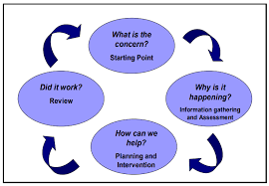

The Continuum of Support suggests the following levels of support
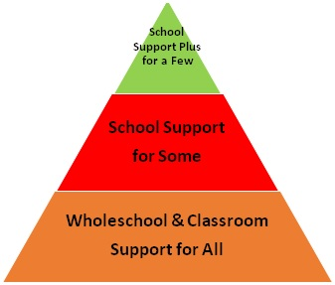
- Whole School & Classroom Support
Classroom Support is the most common, and typically the first response to emerging needs. It is a response for students who have distinct or individual educational needs and who require approaches to learning and/or behaviour which are additional to or different from those required by other students in their class.
Problem-solving at this level typically begins when a parent or teacher has concerns about an individual student. The subject teacher considers how to differentiate the learning programme effectively to accommodate the needs of all students in the class. The teacher may discuss the nature of the problem with parents and consider strategies that may be effective. Classroom Support incorporates the simple, informal problem-solving approaches commonly used by subject based teachers to support emerging needs.
- School Support
In some cases, interventions at classroom support level are not enough to fully meet students’ special educational needs. Therefore, School Support may be required. The subject teacher needs to involve the Special Educational Needs Team (SEN Team) in the problem-solving process at this point as it involves more systematic gathering of information and the development and monitoring of a School Support Plan.
Support at this level can take many forms, for example: team-teaching, small group or individualised tuition, peer mentoring, inclusion in social skills groups, behaviour reward and consequence systems. A Support Plan operates for an agreed period of time and is subject to review.

- School Support Plus
If a students’ special educational needs are severe and/or persistent, they are likely to need intensive support. School Support Plus will generally involve personnel outside the school team in the problem solving, assessment and intervention process. However, the information from Classroom and School Support work will provide the starting point for problem-solving at this level. Classroom support and school support will continue to be an important element of his/her individual education plan.
The flow diagrams below outline how we gather information to identify needs and support students with additional needs. A more comprehensive explanation of each stage can be found in the Continuum of Support for Post Primary Schools– Guidelines for teachers.
https://www.education.ie/en/The-Education-System/Special-Education/Guidelines-forPost-Primary-Schools-Supporting-Students-with-Special-Educational-Needs-inMainstream-Schools.pdf

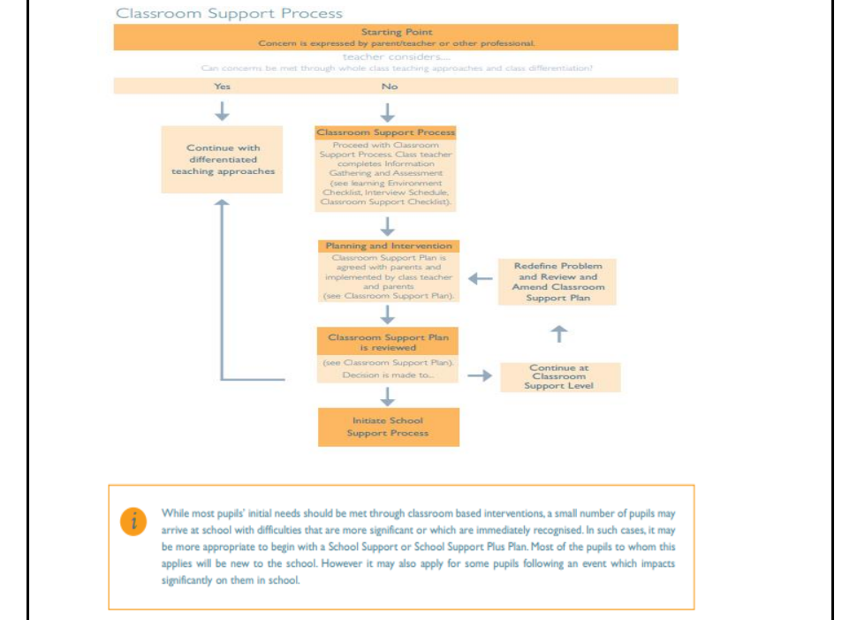

*** adapted from NEPS Continuum of Support. For more detailed steps, see page 12-15
of the Continuum of Support-Guidelines for teachers
https://www.education.ie/en/Schools-Colleges/Services/National-EducationalPsychological-Service-NEPS-/neps_special_needs_guidelines.pdf

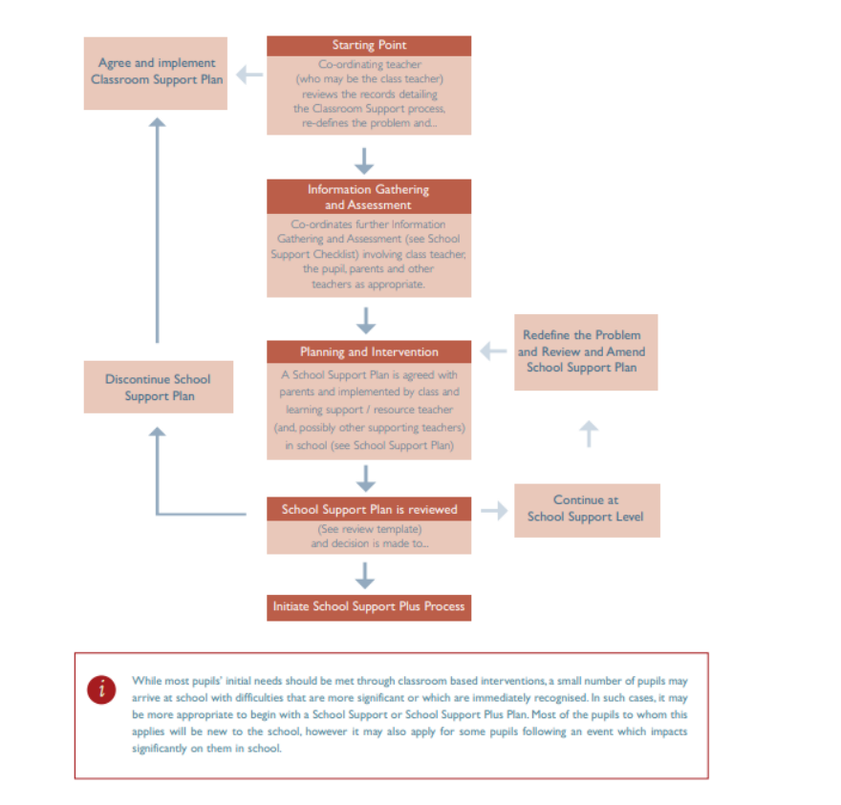
*** adapted from NEPS Continuum of Support. For more detailed steps, see page 22-25
of the Continuum of Support-Guidelines for teachers.
https://www.education.ie/en/Schools-Colleges/Services/National-EducationalPsychological-Service-NEPS-/neps_special_needs_guidelines.pdf

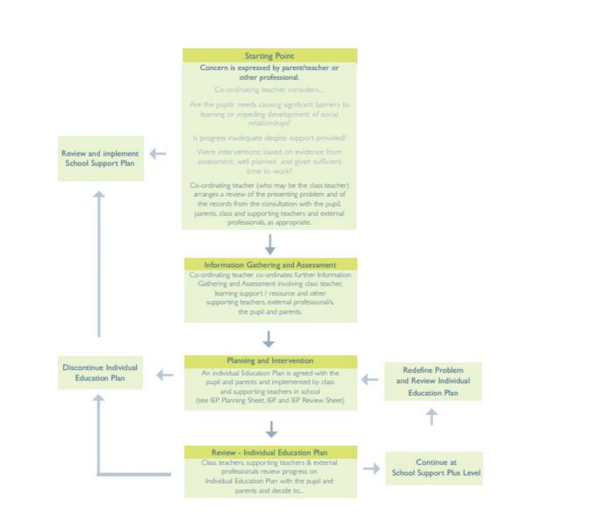
*** adapted from NEPS Continuum of Support. For more detailed steps see page 32-35
of the Continuum of Support-Guidelines for teachers.

https://www.education.ie/en/Schools-Colleges/Services/National-EducationalPsychological-Service-NEPS-/neps_special_needs_guidelines.pdf

Information Gathering and Assessment
Assessment is part of what a subject teacher does on a daily basis for all students. Some methods include self-assessment, questioning, teacher observation, portfolios of work and teacher-designed tasks and tests. The information gathered enables the teacher to plan learning experiences based on the appropriate objectives from the curriculum.
In order to identify students who may require Additional Education, screening including standardised testing are conducted and further diagnostic testing may need to take place. The information gathered from these formal assessments are then used to inform decisions for support and student’s support plans.

Assessment and Screening Tests (for more information see: Diagnostic Assessment policy)
The following assessment procedures are carried out:
- 1st Years- Screening tests include: CAT4, NGRT, WRAT5, DASH
- 2nd Years/ 3rd Years: WRAT5, DASH for RACE
- 4th Years/ 5th Years: DATS
- 6th Years: DARE testing - WRAT5
- Additional tests include: Dyslexia Screening, EAL tests.
We continually review the assessment and screening tests that we use in order to balance the needs of our students and the need to provide information for appropriate support.

Prevention and Early Intervention Strategies
Our strategies for preventing learning difficulties include:
- The development of agreed approaches (SSE) to the teaching of Literacy and Numeracy in order to ensure progression and continuity from year to year.
- Provision of additional support in language development and any relevant early literacy (e.g. Vocabulary Enrichment Programme), mathematical skills (e.g. Numicon) and social skills to students who need it.
- Close collaboration and consultation between teaching staff and AEN team.
- Promotion of literacy e.g. Print-rich environment,
- Promotion of Numeracy e.g. Numeracy Notice-Board, National Maths Week.
- Differentiation and adapting the learning environment.
- In-class support from SNAs and SETs.
- Lunch-time clubs/ activities.
- Team-teaching/ Co-teaching/Withdrawing individuals/groups

Meeting the Needs and Allocating Resources
Targets will be set for students’ based on: students’ profile, history and previous diagnosis, achievement test results, teacher observation, and test/exam results, amongst others.
- A withdrawal system for groups will then be operated whereby students will be removed from appropriate classes on a timetabled basis. Additional one-to-one classes/ small group will be supplied on a very limited basis where a need exists and cannot be catered for in any other manner. Including L2LP provision.
- Team teaching/in class support approach will also be used where possible and as appropriate.
- AEN allocation will be used to create smaller class sizes where this need as this has proven to is to offer the best possible environment to promote e.g. numeracy and literacy development by splitting English and Maths classes. History has also been identified as a specific difficulty for many students with AEN- splits; team teaching will be used to address this. Splitting CSPE/ SPHE/ Coding classes has also proven to be very effective at addressing AEN social, organizational, and communication/ IT skills in a positive environment reducing stigma as this has been identified as a negative feature of withdrawal in our setting.

Timetabling
When drawing up timetables it is important to remember that:
- interruptions to classes/classrooms should be kept to a minimum.
- timetabled SET and subject teachers have the necessary skillset to tackle the student needs that are to be targeted, e.g. literacy, numeracy, social skills etc.
- SNAs will be shared amongst students.
- timetables are continually reviewed.

Tracking, recording and reviewing progress/Student Support Plans/Files
A Student Support Plan (SSP) is devised for students with AEN. All students listed on the AEN register have a SSP which facilitates the tracking and monitoring of specific targets. Students’ progress is also monitored including specific interventions, levels of support and referrals. Students with emerging needs may be moved from school support for all or some to School Support Plus.

Compiling the Student Support Plan involves:
- Gathering information, this includes student passports, psychological reports, liaising with parents, outside agencies, and liaising with primary school SEN department/ class teacher.
- Building a profile base on formal and informal assessments.
- Establishing AEN provision.
- Establishing Priority Needs.
- Consulting with subject teachers and take on board teacher observations.
- Carrying out a subject survey, if necessary.
- Identifying strategies required.
- The AENCO setting targets for priority learning needs. SETs then liaise with the subject teacher to plan work for students, create targets that are more detailed, monitor, and review these targets every term and report progress to the AENCO. This is all recorded in a OneNote document.
- Deciding a review date. SETs review targets for their groups in a OneNote document shared with the AENCO, principal and other SET. SETs discuss pertinent issues surrounding students on their caseload with the AENCO.
- Providing access to the Student Support Plan and Personal Pupil Plan of students on VSware.

Provisions for Students with emerging needs
For students with emerging needs, including the exceptionally able, the concern may have been identified through the whole school screening and monitoring systems (CAT4, informal observation, parental concern).
Throughout the school year teachers are asked to complete a referral form for students if they have concerns about a student (see Appendix 2). Some students will need further individual or diagnostic testing to identify the nature of their needs (both learning and behavioural). Teachers may be asked to complete a student progress report. In-house and state examination results will be monitored.

Resources
AEN teachers and students have no access to a specialist AEN room at present. We are awaiting a new build with 2 AEN rooms.

Reasonable Accommodations for Certificate Examinations (RACE) and In-house Examinations
RACE accommodations are applied for annually in line with SEC guidelines at that time. Further details are available in the RACE Guide for Exam Students at www.examinations.ie.
Where resources permit, and when deemed appropriate, readers, scribes, spelling and grammar waivers and other accommodations are available to students who meet the SEC criteria for reasonable accommodations at mock exams and other school assessments (see letters for RACE in Appendix 3).

Record Keeping
- A full record of psychological reports, CAT results, student passports and other reports are kept in the AEN co-ordinators office in a locked filing cabinet. Records of AEN meetings are kept on Microsoft Office 365. Mainstream teachers can access student’s information in the AEN co-ordinators office but the information may not be removed from the office.
- Student Support Plans and Personal Pupil Plans are stored on VSware and Microsoft Office 365.
- Information is managed in accordance with the directives of both the Freedom of Information and Data Protection Acts. Student records are destroyed after 7 years.

Assistive Technology
If a student has a recommendation in a professional report that assistive technology is essential with details of the assistive technology needed, an application may be made to the SENO as per Circular No 0010/2013.
If this application is successful, equipment will be purchased using funds provided by the NCSE (National Council for Special Education). Although the equipment will be sanctioned for a particular pupil the equipment will, as a rule, remain the property of the school and will be available for allocation to subsequent pupils with similar disabilities. (For more information please see our ICT and Code of Behaviour Policies).

See Appendix 4 for the AEN Dapartment information letter for students/parents/guardians for the use of Assistive Technology.

Exemptions from Irish and Foreign Languages
- The guidelines set down by the Department of Education will be strictly adhered to (Department of Education Circular 0055/2022- Exemptions from the study of Irish – post primary, see https://www.gov.ie/en/circular/f33d5-exemptions-from-the-study-of-irish-post-primary/)

Ratification and Communication
This revised policy was ratified by the Board of Management on _______________________.

Implementation and Review
This policy will be implemented from _________. It will be reviewed by the Special Education Team and all staff in _________________.
Signed: __________________ Date: _______________________
(Chairperson)

Appendix 1

Definitions:
(a) Students with special educational needs are those who are restricted from participating in and benefiting from education on account of an enduring physical, sensory, mental health or learning disability, or any other condition which results in a person learning differently from a person without that condition. (EPSEN Act 2004).
(b) Exceptionally able students are those understood to require opportunities for enrichment and extension that go beyond those provided for in the general cohort of students.

Categories of Special Education Needs (SEN):
To date, the school has provided for the following categories of students with AEN:
- Borderline/Mild General Learning Disability
- Social Emotional Behavioural Difficulties (SEBD)
- Specific Learning Difficulty – Dyslexia
- Physical Disabilities- Dyspraxia, Cerebral Palsy
- Specific Language Impairment (SLI)
- Sensory Difficulties (Hearing and Visual Impairments)
- Moderate Learning Disability
- Autism/ Autistic Spectrum Disorder (e.g.: Asperger’s Syndrome)
- Exceptionally able students
- EAL (English as an Additional Language)
In addition to these categories we understand that under circular 08/02 (Appendix 3) the following categories of SEN exist also:
- Down’s Syndrome
- Moderate General Learning Disability
- Severe / Profound General Learning Disability

Appendix 2
SEN Referral
Copy and paste onto a new document and email referral to me.
Alternatively, please print and leave in room 3/ my cubbyhole.

Date: Referring person’s name:

Student name: Role: SNA / Teacher / Year Head/ Tutor/ Learning Support Teacher

Priority concerns:

- No SEN diagnosis but student has persistent difficulties: literacy / numeracy / motor skills / behavioural / emotional / social

- Persistently not hitting Student Support Plan targets in Learning Support Classes / Team Teaching

- Ongoing student difficulties accessing the curriculum (please attach copy of test results for Student Support File)

- Not using SEN resources as allocated (Assistive Technology, SNA support, Homework Club, etc.)

- Other:

Supporting information:

Classroom strategies implemented:

1.)

2.)

3.)

* Information from this referral form will be discussed at Student Support Meetings / SEN Team Meetings.

Appendix 3
Principal: Eimear Harte Grange, Co. Sligo
Príomhoide: EimearUí hAirt An Ghráinseach, Co. Shligigh
Deputy Principal: Ms Maranna Grimes E-mail: secretary@grangepps.ie
Leasphríomhoide: Áine Mhaire Ní Ghreim Tel: 071-9163514
Fax: 071-9163118

RE: RACE FOR SUMMER TESTS
___/___/___
Dear Guardian/ Parent,
Under current State Examination Commission guidelines, testing for Reasonable Accommodations for State Examinations are not undertaken until 3rd Year. This means that until that point we can only give a best estimate of what RACE your child may receive for state examinations.
School-based accommodations are given in first and second year on the basis of 1st Year Screening and analysis of supplementary documentation provided to the school by the parent.
This means your child may have access in term tests to accommodations such as a Spelling, Grammar and Punctuation waiver, Reading Assistance, access to Assistive Technology, Rest Breaks, amongst others.
From our knowledge so far, your child is provisionally being offered the following school-based RACE in term tests.
o Spelling, Grammar and Punctuation Waiver o Scribe
o Reading Assistance o Use of Assistive Technology
o Shared Centre o Individual Centre
Other: ________________________________

This does not mean that they are eligible for the same in state examinations. The State Examinations Commission (SEC) change their eligibility standards every year and schools are required to strictly adhere to their criteria for eligibility.
The SEC state that testing for RACE can only take place in school. Testing is to take place at the end of 2nd Year/ beginning of 3rd Year. Earlier results of testing undertaken by the school or any other professional is considered outdated and therefore, ineligible.
Yours faithfully,
________________________ __________________________
Orla Sills, AENCO Eimear Harte, Principal
-----------------------------------------------------------------------------------------------------------------
I have received the above correspondence in relation to school-based RACE for my child ________________ (name). Please return this slip to the school.
Signed: ________________________ PRINT NAME: ____________________________

Principal: Eimear Harte Grange, Co. Sligo
Príomhoide: EimearUí hAirt An Ghráinseach, Co. Shligigh
Deputy Principal: Ms Maranna Grimes E-mail: secretary@grangepps.ie
Leasphríomhoide: Áine Mhaire Ní Ghreim Tel: 071-9163514
Fax: 071-9163118

___/___/___
RE: RACE FOR JC STATE EXAMINATIONS
Dear Guardian/ Parent,
Your child is eligible for assessment for Reasonable Accommodations in Certificate Examinations (RACE).
To date your child may have had some provisional school based RACE in term tests (as a result of first year screening test results or on analysis of supplementary documentation provided by you). Accommodations your child may have had included; Spelling, Grammar and Punctuation waiver, Reading Assistance, access to Assistive Technology, Shared Examination Centre, Rest Breaks, amongst others.
This does not mean that they are eligible for the same in state examinations. The State Examinations Commission (SEC) change their eligibility standards every year and schools are required to strictly adhere to their criteria for eligibility.
The SEC state that testing for RACE can only take place in school. Testing is to take place at the end of 2nd Year/ beginning of 3rd Year. Earlier results of testing undertaken by the school, or any other professional, is considered outdated and therefore, ineligible.
Over the coming weeks and months your child will be tested in school to check if they meet the threshold as stipulated by the SEC for RACE.
After all testing has been completed (this usually happens in the first semester of 3rd Year) the SENCO/ SET will contact you to let you know if your child has reached the threshold to apply for RACE to the SEC.
All candidates who meet the threshold for RACE will have applications prepared by the school on their behalf, and with parental consent, they will be forwarded to the SEC. Only the SEC can confer eligibility for RACE, i.e. they award RACE. The results of this process are available around March of 3rd Year.
For more information on what this means please see the State Examinations Website and click on the Candidates tab and then Reasonable Accommodations: https://www.examinations.ie/?l=en&mc=ca&sc=ra
Please complete below to allow your child to undergo testing for RACE.
Yours faithfully,
______________________ ____________________
Orla Sills, AENCO Eimear Harte, Principal
-----------------------------------------------------------------------------------------------------
I DO / I DO NOT allow my child _____________________(name) to undergo testing for Reasonable Accommodations in State Examinations. Please return this slip to the school.
Signed: ________________________ PRINT NAME: ____________________________

Principal: Eimear Harte Grange, Co. Sligo
Príomhoide: EimearUí hAirt An Ghráinseach, Co. Shligigh
Deputy Principal: Ms Maranna Grimes E-mail: secretary@grangepps.ie
Leasphríomhoide: Áine Mhaire Ní Ghreim Tel: 071-9163514
Fax: 071-9163118

RE: RACE TESTING FOR JC- OUTCOME

___/___/___
Dear Guardian / Parent,
Following testing, your child has / has not reached the threshold for Reasonable Accommodations in Certificate Examinations (RACE) as stipulated by the State Examinations Commission (SEC).
The next step is:
o The school will proceed no further with RACE, as your child has not reached the threshold.
OR
With parental consent, the school will apply for (see below) on their behalf:
o Spelling, Grammar and Punctuation Waiver o Scribe
o Reading Assistance o Use of Assistive Technology
o Shared Centre o Individual Centre
Other: ________________________________
They did not reach the threshold for any other accommodation, as stipulated by the State Examinations Commission.
Following receipt of the application, the State Examinations Commission will make the final decision on whether or not your child has been granted RACE. This information is usually released by March of 3rd Year.
For more information on what this means please see the State Examinations Website and click on the Candidates tab and then Reasonable Accommodations: https://www.examinations.ie/?l=en&mc=ca&sc=ra
Over the coming weeks, please expect a phone call asking for you come to the school to sign the RACE document.
Junior Cycle accommodations may be reactivated for Leaving Certificate at the discretion of the SEC.
For more information, please contact the school on 071 9163514 to discuss with the SENCO.
Yours faithfully,
______________________ ____________________
Orla Sills, AENCO Eimear Harte, Principal
-----------------------------------------------------------------------------------------------------------------
I have received the above correspondence in relation to RACE for my child ________________ (name). Please return this slip to the school.
Signed: ________________________ PRINT NAME: ____________________________

Principal: Eimear Harte Grange, Co. Sligo
Príomhoide: EimearUí hAirt An Ghráinseach, Co. Shligigh
Deputy Principal: Ms Maranna Grimes E-mail: secretary@grangepps.ie
Leasphríomhoide: Áine Mhaire Ní Ghreim Tel: 071-9163514
Fax: 071-9163118

RE: RACE REACTIVIATION/ APPLICATION FOR LC STATE EXAMS
___/___/___
Dear Guardian / Parent,
I am writing to you to discuss applying for or reactivating Reasonable Accommodations in Certificate Examinations (RACE) for the Leaving Certificate Examinations.
o For Junior Certificate, your child was not deemed eligible for any RACE at Junior Cycle, but in the light of new evidence, and with parental consent, we will draw up an application for _____________________________________________________________________________________
OR
For Junior Certificate the State Examinations Commission (SEC) deemed your child eligible for the following Reasonable Accommodations in Certificate Examinations:
o Spelling, Grammar and Punctuation Waiver o Scribe
o Reading Assistance o Use of Assistive Technology
o Shared Centre o Individual Centre
Other: ________________________________

They did not reach the threshold for any other accommodation, as stipulated by the State Examinations Commission.

Please consent for the SENCO to apply to the SEC to reactivate these RACE.
Following receipt of the application, the State Examinations Commission will make the final decision on whether or not your child has been granted RACE. This information is usually released by March of 6th Year.
For more information on what this means please see the State Examinations Website and click on the Candidates tab and then Reasonable Accommodations: https://www.examinations.ie/?l=en&mc=ca&sc=ra
Over the coming weeks, please expect a phone call asking for you come to the school to sign the RACE document.
Yours faithfully,
______________________ ____________________
Orla Sills, AENCO Eimear Harte, Principal
-----------------------------------------------------------------------------------------------------
I DO / I DO NOT allow my child _____________________(name) to undergo testing for Reasonable Accommodations in State Examinations. Please return this slip to the school.
Signed: ________________________ PRINT NAME: ___________________________

Appendix 4

Dear Student/Guardian/ Parent,

You are receiving this letter because an Occupational Therapist/ Psychologist/ Psychiatrist/ Visiting Teacher or other professional has recommended you/ your child use assistive technology.

Included below are some implications around the use of assistive technology that we wish to make you aware of so you can make an informed decision in relation to your child; in particular, some of the current requirements of the State Examinations Commission (SEC). It is important that you discuss these with your son/daughter before opting to use this accommodation.

- General Grange P.P.S. guidelines for the use of Assistive Technology for students

- Students using a laptop and typing
For students with who have reports recommending assistive technology and who wish to pursue the use of assistive technology, teachers have been alerted that this has been recommended.

In our setting, typing on laptops has been found to be the most beneficial form of assistive technology. Therefore, we recommend a free typing programme called Typing Club with step by step instructional videos to improve typing proficiency, see link below. We suggest it is used for 10 minutes per evening https://www.typingclub.com

The student must agree with each subject teacher how the laptop will be used daily within that subject, e.g. for homework, class assignments, Junior Cycle Assessment Tasks etc.

- Students using speech to text
For students who have received approval from the SENCO (Ms Sills) to use speech to text, teachers will be notified of this particular accommodation.
Please be aware that this accommodation needs to be practiced daily as it can be difficult to navigate.

The student must agree with each subject teacher how to use speech to text daily in their classes e.g. for homework, class assignments, Junior Cycle Assessment Tasks etc.

- Student responsibilities
It is the student’s responsibility to use the laptop. Teachers will be advised that they have access to a laptop, but the responsibility falls on the student to use this accommodation.

It is the student’s responsibility to:
1. Have their laptop charged before school
2. Have them present in school everyday, and especially on test days
3. Ensure laptops are maintained in line with the school’s Acceptable Use Policy.
4. Store the laptop securely. The school will not take liability for loss or damage of laptops/devices, including personal devices.
5. Sign a contract before using laptops issued by the Department of Education. Students must adhere to that contract while using the laptop.

Please see additional relevant school policies for further information, ICT/ Acceptable Usage Policy, Code of Behaviour, Child Protection, Anti-Bullying at https://grangepps.ie/policies/

- Opting out of assistive technology use

Your child may decide not to use assistive technology despite having been recommended it by a professional. If this is the case, the parent/ guardian must inform the SENCO in writing.

Please note, if you opt out of the use of assistive technology at any point, the State Examinations Commission (SEC) may not grant the use of technology for state examinations at a later stage. The SEC state, to be eligible for the use of assistive technology for state examinations, students must show evidence of need and use “ assistive technology for day to day schooling and [all] in-house examinations” (SEC, 2022, p.27).

If students are not using assistive technology daily the State Examinations Commission (SEC) argue they do not need it for state examinations and therefore are ineligible to apply for this accommodation.

Please note, where it is established that a student is not daily using a laptop granted by Department of Education, the school will request that the laptop is returned to school.

- Information from the State Examinations Commission (SEC) 2022

SEC criteria for eligibility for the use of assistive technology Reasonable Accommodations in State Examinations (RACE)

- A diagnosis does not necessarily make a student eligible for use of assistive technology in state examinations

The SEC have strict eligibility criteria for RACE. They state a candidate’s diagnosis does not automatically confer eligibility for any accommodation, i.e. “where a professional report recommends that a particular accommodation is to be provided, they are to treat it as a recommendation to the school on behalf of the candidate. Such recommendations do not confer eligibility for supports ...” (SEC, 2022, p.56).

The SEC require that students also:
- Undergo achievement testing and fall under strict criteria
- Show evidence of a continued need (continued daily use) for assistive technology

Therefore, a student may be deemed ineligible for the use of assistive technology by the SEC if, for example, they have a diagnosis of dysgraphia or ASD but their writing speed is within the normal range.

- Poor handwriting

Poor handwriting alone also does not qualify your child for assistive technology in state examinations. The SEC state, “Examiners engaged by the SEC are very skilled, from both their teaching and examining experience, at interpreting the handwriting of candidates and will make every effort to ensure that all work presented in the examinations is understood and marked fairly. In any case where they find themselves unable to read the script they are instructed to refer it to a senior, more experienced examiner who will, if necessary, engage with other experts in accessing the work” (SEC, 2022, p.58).

- Scribes

Psychologists may suggest the use of a scribe in their report. However, in practice, the SEC have very strict criteria around the use of this accommodation, i.e. the use of a scribe is declined by the SEC for the majority of students who apply. The SEC state the use of scribes are only for “very exceptional circumstances” (SEC, 2022, p.16).

If a scribe is granted at Junior Cycle it is highly unlikely to be repeated at Leaving Certificate. “In particular, we do expect that a candidate granted access to a scribe at Junior Cycle should, following interventions at school during senior cycle, have become sufficiently proficient in the use of a Word Processor or Recording Device to enable them to make use of one of these accommodations at the Leaving Certificate examinations” (SEC, 2022, p.8).

- Additional time in state examinations

Although some psychologist reports suggest that students may be eligible for additional time in exams, please note, the SEC state, “Under no circumstances will a candidate granted the use of a word processor (or other device) be allowed extra time to type their responses on grounds of slow typing speed” (SEC,2022,p.17). The SEC expect students to be proficient at typing through their daily use of laptops. If this is not the case, they are to use other accommodations, e.g. speech to text, please discuss this with the SENCO as soon as possible as this is a challenging accommodation to adjust to. Again, students must practice any new accommodation daily.

- Digital booklets

Digital booklets are available for some subjects with coursework elements in Senior Cycle (Geography, Home Economics, and Agricultural Science) and for Junior Cycle Assessment Tasks. In the first instance, please discuss this with the subject teacher who will then refer requests to the SENCO.

Please be aware, to access digital booklets the SENCO must email the SEC the students’ “name, PPSN and date of birth, the subject requested and reason for the request”. The digital version will be issued once the SEC is satisfied as to the eligibility of the candidate for accommodations under the RACE scheme” (SEC, 2022,p.27).

- Shared Special Examination Centres

“Shared special examination centres are approved for reasonable accommodations for the following reasons: 1. Use of a word processor…” (SEC, 2022, p.21). Please note, shared centres generally have up to 8 candidates present. “For candidates who are recording [e.g. text to speech] their answers” (SEC, 2022, p.20) they are eligible for an individual centre.

“Candidates must return to the main examination centre if they do not use the accommodation that led to the granting of a special examination centre” (SEC, 2022, p.14). This means if you are not using a laptop for your exam you will be returned to the main centre.

- Exam protocols

The SEC states, “Candidates that have been granted the use of a word processor to complete their examinations and are submitting a word-processed script, must follow the instructions for the setting up, saving and getting a script ready for return at the end of the examinations” (SEC, 2022,p.48). These instructions will be given to students when they are granted a word processor- it is the student’s responsibility to familiarise themselves with these instructions.

If your child is not eligible for a spelling, grammar and punctuation waiver, please ensure spell-check and auto-correct are turned off at all times, as they will not be able to use these accommodations in-house and state examinations (SEC, 2022, p.54). It is the students and parents responsibility to ensure these are disabled.

Please note, when it comes to state examinations students who have been granted a laptop for school will have to use a different school laptop for exams, which will be set up in-line with SEC guidelines to ensure the integrity of the state examinations.

Use of a laptop granted by the SEC “at Junior Cycle will be reactivated at Leaving Certificate subject to confirmation by the school authority of an identified and continuing need”, (SEC, 2022, p.7), i.e. continued daily use in 4th, 5th and 6th year.

I hope this information on assistive technology is useful. Please be aware, the information above is subject to change as the SEC issue instructions to schools on an annual basis. If you need to discuss anything further with me, please contact the school at 071 9163514.

Yours faithfully,
Orla Sills,
AENCO

