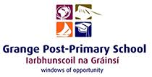
Mandatory Template 3: Notification regarding the Board of Management’s review of the Child Safeguarding Statement

To: All stakeholders of Grange Post Primary School Sligo.

The Board of Management of Grange Post Primary School wishes to inform you that:

- The Board of Management’s annual review of the school’s Child Safeguarding Statement was completed at the Board meeting of 26/11/25

- This review was conducted in accordance with the “Checklist for Review of the Child Safeguarding Statement” published on the Department’s ‘website www.education.ie

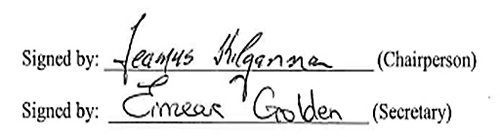  Signed by: (Chairperson) | Date: 26/11/25
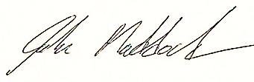  Signed by: (Secretary) | Date: 26/11/25

