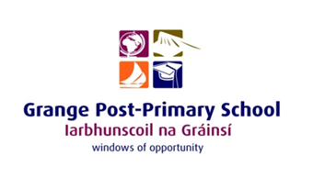

GRANGE PPS BOARD OF MANAGEMENT
MEETING 2
AGREED REPORT

Agreed Report: 10th November 2025

- The board approved the minutes from the previous meeting.
- The Board formally ratified Seamus Kilgallon as Chairperson for the 2025–2026 school year.
- The Board welcomed John Maddock as principal and wished him well in his new role at Grange Post Primary School.
- The principal expressed his appreciation for the warm welcome from staff and acknowledged the strong culture of care and excellence within the school.
- The Board received correspondence from third level institutions thanking the school for facilitating student placements.
- The Board noted the Principal’s Report, including updates on the school’s Open Evening, building updates, and student and school team achievements.
- The Board commended staff and students on the very strong Leaving Certificate results and expressed appreciation for their commitment and hard work.
- The principal provided the Board with an update on the progress of School Self Evaluation.
- The principal presented the Child Protection Oversight Report and the Anti-Bullying report to the Board

