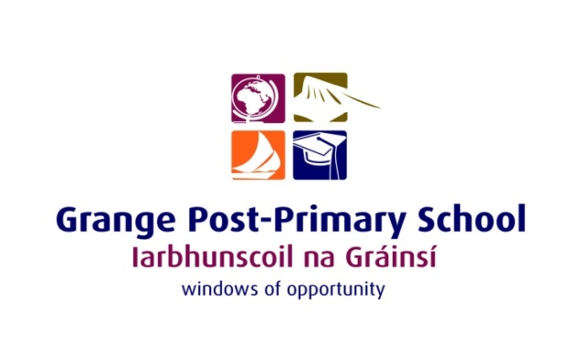

GRANGE PPS BOARD OF MANAGEMENT
MEETING 1
AGREED REPORT

Board of Management Meeting, 9th September 2025

- The board approved the minutes of the previous meeting
- The Board ratified the allocation of roles and responsibilities to post holders in line with the agreed schedule of posts.
- The Board approved the updated Child Safeguarding Statement and Risk Assessment.
- The Board ratified the updated Code of Behaviour, the Admissions Policy (including the Annual Admissions Notice), and the updated Critical Incident Policy.
- The Board noted and commended the positive outcomes of the Leaving Certificate results and expressed appreciation to the teaching staff for their hard work and dedication.
- Statutory Child Protection Oversight and Anti-Bullying reports were presented and approved.
- The Board welcomed the progress on facilities over the summer months, including refurbishment and new equipment.
- The Board commended the continuing development of ICT, teaching and learning, and acknowledged the work of staff in strengthening SEN and guidance provision.
- The Board welcomed the election of a new Student Council and commended their ongoing contribution to student voice in school life.
- The Board extended best wishes to Paul Kelly in his new role and expressed thanks for his contribution as Acting Principal.

